Oswald Medical Centre
Minutes of Meeting

Date: 9th October 2024 |  | Attendees:
Meeting Title: Patient participation group |  | Rita Naylor, Senior Business Manager (RN)
Agenda - |  | Steph Driver, Practice Manager (SD)
Matters arising |  | Stacy Feeney, Minute Taker (SF)
Terms of reference (discuss/agree) |  | Monica Green (MG)
Ground rules for meetings (discuss/agree) |  | John McCormack (JM)
Flu Clinics |  | Colette McCormack (CM)
BMA Collective Action |  | Apologies or on leave:
Enhanced access and respiratory clinics |  | Michael Ratcliffe (MR)
AOB |  | Carole Ratcliffe (CR)
 |  | Val Stephenson (VS)

Items discussed and brief notes of discussion: | Actions agreed and to whom allocated
Matters arising:  RN went through the staffing that was discussed via presentation at the first meeting back in July, for the new members as well as the budget for the NHS with Primary care receiving a total of 9% but carrying out 90% of the whole of NHS contacts.  There were also some suggestions made by PPG members which included door access to the building. RN has been discussing this with the architect. There have been some very expensive quotes for automatic doors Discussions have also taken place regarding the possibility of installing a lift at the Oswaldtwistle site and creating some more consultation rooms upstairs which will help alleviate some of the room pressure we have with the numerous ARRs roles we have in Practice. RN has also approached NHS England to see if there are any accessibility grants we may be able to claim. RN also made members aware that we do have disabled parking on the bottom car park.  *************************  Another issue raised was the radio being too loud at the Oswaldtwistle branch meaning receptionists were talking quite loudly to patients. The Care Navigators have undergone some training around this, and work is ongoing around the desks and installing a telephone at the front desk | Email presentation to new members
Flu Clinics:
SD handed out the information below and this was discussed.
Flu So Far (practice setting):
65+ = 425 vaccines given for 2024/2025 (2566 eligible = 16% of eligible patients vaccinated in the surgery)
18-64 year olds at risk = 165 vaccines given for 2024/2025 (2551 eligible = 7% of eligible patients vaccinated in the surgery)
2 and 3 year olds = 25 vaccines given for 2024/2025 (321 eligible = 7% of eligible patients vaccinated in the surgery)
Upcoming Clinics (in addition to patients being vaccinated in non-dedicated clinics):
09/10/2024 | Darcy | Accrington | Pregnant Ladies / Nasal flu / under and over 65s
 | Kat
 | Amber | CARE HOMES WITH OLGA & DONNA | Under and over 65
11/10/2024 | Kat | Accrington | Pregnant Ladies / Nasal flu / under and over 65s
 | Jan |  | Under and over 65
16/10/2024 | Darcy | CARE HOMES WITH OLGA & DONNA | Under and over 65
17/10/2024 | Kim | Blackburn | Pregnant Ladies / Nasal flu / under and over 65s
19/10/2024 (Saturday) | Kim | Oswaldtwistle | Pregnant Ladies / Nasal flu / under and over 65s
 | Kat |  | Pregnant Ladies / Nasal flu / under and over 65s
 | Natasha |  | Under and over 65
23/10/2024 | Darcy | CARE HOMES WITH OLGA & DONNA | Under and over 65
31/10/2024 | Kim with Tracey | HOUSEBOUND | Under and over 65
07/11/2024 | Kim with Tracey | HOUSEBOUND | Under and over 65
MG raised concerns around the children ages 4 – 17 and where they receive their vaccination as she was not aware that this is done in the school setting.
We have had some amazing feedback about our ‘Flu Fighter’ Clinics where the children received a balloon and a party bag with a bravery certificate. This month we received 92% positive feedback in the Friends and Family Test and one of the comments was around the ‘FLU FIGHTER’S’ parties held:

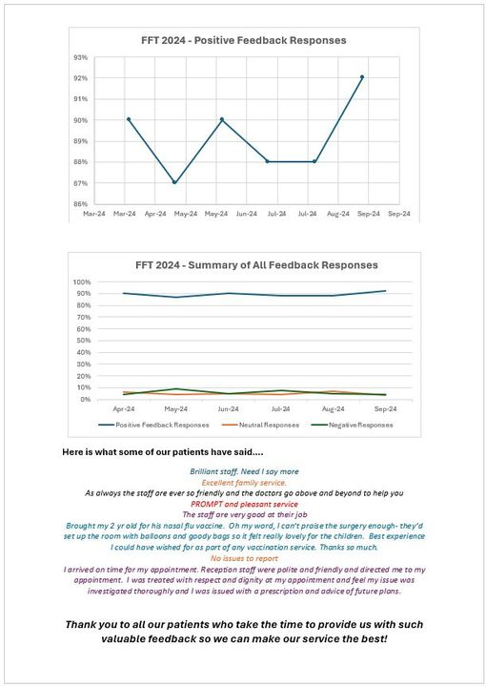
Alongside the Flu vaccinations, we have also been vaccinating against Pneumonia and Shingles as well as the new RSV (respiratory syncytial virus. MG queried the age ranges for the recall of these vaccines. RN explained its National guidelines which we must follow and cannot administer out of these ages. CM said the TV adverts are very confusing around the ages eligible.
BMA Collective Action:

It has been covered in the news regarding industrial action by GPs. There are 10 recommendations from the BMA (British Medical Association) of actions that they support our GP’s taking. Out of the 10 recommendations, will be taking part in 8 of them.
The point we are not taking part in is;

2, Switch off Medicines Optimisation Software embedded by the local ICB for the purposes of system financial savings (rather than the clinical benefit of your patients). We haven’t switched this off. As a practice, we feel we need to be responsible with public money and the medicines optimisation scheme that is embedded locally is something we support, especially as this seeks to focus prescribing on NICE Guidelines and non-branded medicines which save the NHS money.

The point we are partially implementing is:

1-Limit daily patient contacts per clinician to 25. We know that the NHS has a lack of appointments across the system and part of the frustration with lack of GP appointments is the alternative - patients facing long waits at urgent care. To continually underpin this lack of provision stifles the speed of solutions for the NHS as a whole. That being said, we do not want patients to delay care or treatment, especially where they are vulnerable or face barriers to accessing care and treatment. Instead the practice will partially implement this and ensure that effective Care Navigation is taking place including the following measures:
- Limit patient contacts of the Duty Doctor to 25 per day wherever possible – ensuring that any requests which exceed capacity are dealt with in alternative ways wherever possible:
  - Extensions to acute medicines may be dealt with by a Pharmacist or outside of an appointment
  - Promote the use of ARRS roles eg physiotherapist, Health and Wellbeing Coach etc
  - Opening more book in advance appointments to allow prioritisation
  - Responding to requests for FIT notes outside of an appointment
  - Being clear with patients about the difference between NHS and non-NHS work
  - Referring patients to alternative services eg 111, extended access, acute visiting services etc

The actions we will be taking are:

3-Serve notice on any voluntary services currently undertaken that plug local commissioning gaps and stop supporting the system at the expense of your business and staff. This includes tests/monitoring requested by secondary care, inappropriate transfer of work, follow-up of rejected referrals etc.

4 -Stop rationing referrals, investigations, and admissions​
As always, we will refer, investigate or admit patients for specialist care when it is clinically appropriate to do so, even where this is in opposition to recommended care pathways imposed or designed by secondary care. ​

8 - Refer via eRS for two-week wait (2WW) appointments, but outside of that write a professional referral letter in place of any locally imposed proformas or referral forms where this is preferable. It is not contractual to use a local referral form/proforma

5-Switch off GPConnect Update Record functionality that permits the entry of coding into the GP clinical record by third-party providers. This includes secondary care providers adding medication for repeat prescribing to patient records without consulting with the responsible GP.

6-Withdraw permission for data sharing agreements that exclusively use data for secondary purposes (i.e. not direct care).
7-Freeze sign-up to any new data sharing agreements or local system data sharing platforms.

10- Defer making any decisions to accept local or national NHSE Pilot programmes whilst we explore opportunities with the new Government.

Discussions took place around the Medicine Management Team from the ICB who implement a formulary that ensures effective prescribing and value for money for the NHS – as a practice we feel we must stick to it.

The PPG members also praised our Clinical Pharmacist Areeza and MG asked if there was a wider use for her. SD explained that Areeza is also a Prescriber, and she will be seeing patients going forward for some chronic disease.

JM asked about home visits. SD explained we are strict on home visits. We have lots of patients and in the time a GP takes to do 1 visit, they could have seen 5 patients. We do have the use of AVS (acute visiting service) for those in genuine need of a visit and visits where possible should be requested before 10am. We have 78 known and validated housebound patients registered with the Practice. Dr Sharma informs the patients that we have equipment in the surgery and if an ECG is required, the machine won't be with him on the visit. Lack of transport is not a reason for a home visit.

Enhanced access and respiratory clinics – Information circulated about the ARI (acute respiratory infection) hubs and Extended Access.
The ARI Hub offers patients who have an acute respiratory infection / chronic condition (such as Asthma or COPD) an appointment with a GP or ACP to assess their condition and treat as required.
The Enhanced Access Service has been launched in East Lancashire to increase the number of appointments to patients in the area. The Enhanced Access scheme means that patients can make an appointment via their registered practice to see a variety of Health Professionals such as GPs, ANPs, PNs, HCAs and Clinical Pharmacists which are delivered F2F and remotely Mondays to Fridays from 17:00 – 20:45, and 09:00 – 17:00 on a Saturday.
Terms of Reference (ToF) all in agreement
Ground Rules – all in agreement
Any other business:  Fundraising – MG asked if the PPG are allowed to fundraise for the Practice. SD explained we are limited to gifts and donations to staff, we can never accept anything that may put us in a conflict of interest, however, it was already discussed in the management meeting that perhaps PPG members could do some fundraising for a FeNO machine or perhaps help towards the cost of the automatic doors. We can fundraise for things that will enhance patient care. There is provision for this in our agreed terms of reference but we would need a treasurer with support from the practice initially. JM suggested putting the minutes of the PPG meetings in the waiting room to advertise the PPG. MG suggested standing in the waiting room to talk to the patients. SD stated we need to be clear on our objectives and what we are fundraising for and be transparent in our activities.  *************************  Patients had stated at the previous flu clinic (5/10/24) that it had a ‘Festival Feel’ as we had the PPG, Bowel Screening and a fundraising coffee morning all running together, so it was decided at the next Flu clinic, this would be the ideal time to do a spot of fundraising. As a starter for 10, we are looking at putting on a raffle to begin raising funds for the doors. The Flu Clinic is set for the 19th October 2024. PPG members to arrive at 9am. CR and MR will be in attendance as well as the Bowel Screening stand. RN is going to buy a teddy to raffle and also make a chocolate hamper.  It was also discussed we could do a raffle at Christmas just in reception which wouldn’t take too much time. | All to read the terms of reference.
RN would also like the PPG to help assist in getting awareness to patients who qualify for a council tax rebate. The forms are straight forward but unfortunately, people do not know the rebates exist or if they do qualify. | PPG members to support this – perhaps run an information stand in Reception or assist in a mail out.
Newsletter / Wellbeing magazine – the next issue of the newsletter [DRAFT] was shared with PPG members – this is now being formatted into a PDF file before we can share with patients. PPG Members are asked to contribute to this in future. | PPG members to feel free to share ideas for future issues of the Wellbeing Magazine
Date of next PPG meeting
Wednesday 15th January 2025 – 2pm

